- Launch EC2
- AMI: Amazon Linux 2023
- Instance Type: t3.medium
- Storage: 20 GB gp3
- Public IP: Yes
- Security Group: 22 from my IP
Connect using ssh -i my-key.pem ec2-user@<public-ip>
- Install MySQL 8.0
- sudo dnf update -y #Update packages
- sudo dnf search mariadb #Check Available MariaDB Versions
Or sudo dnf list available | grep mariadb
- sudo dnf install mariadb105-server -y #Install MariaDB Server
- sudo systemctl start mariadb #Start MariaDB Service
- sudo systemctl enable mariadb #Enable Auto Start on Boot
- sudo systemctl status mariadb # check status
- sudo mysql_secure_installation #Secure MariaDB Installation
Set root password? Y
Root user password: admin123
Remove anonymous users? Y
Disallow root login remotely? Y
Remove test database? Y
Reload privilege tables? Y
- mysql -u root -p #Login to MariaDB
SELECT VERSION(); #Verify Installation from mariadb console
- CREATE DATABASE dms_test; #Create DB from mariadb console
SHOW DATABASES; #check DB from mariadb console
- sudo vi /etc/my.cnf.d/mariadb-server.cnf #Edit configuration and make bind-address=0.0.0.0 for allowing remote access and then restart the mariadb service from bash
- Create a Remote User
CREATE USER 'admin'@'%' IDENTIFIED BY 'admin123';
GRANT ALL PRIVILEGES ON *.* TO 'admin'@'%' WITH GRANT OPTION;
FLUSH PRIVILEGES;
- Open Security Group Port 3306
- Login from remote machine
mysqlsh -h <EC2-Public-IP> -u admin -p # Require MySQL shell for windows as client
Or mysqlsh --sql admin@<EC2-Public-IP>:3306

- Migration
- Verify Source Database for DMS
Login to MariaDB:

SHOW VARIABLES LIKE 'log_bin'; # should be ON
SHOW VARIABLES LIKE 'binlog_format'; # should be ROW
SHOW VARIABLES LIKE 'server_id'; # should be 1
If log_bin is OFF, change the mariadb configuration otherwise CDC will not work.
sudo find /etc -name "*.cnf" #to check configuration file
sudo cp /etc/my.cnf.d/mariadb-server.cnf /etc/my.cnf.d/mariadb-server.cnf.bak
sudo vim /etc/my.cnf.d/mariadb-server.cnf
[mariadb]
server_id=1
log_bin=mysql-bin
binlog_format=ROW
binlog_row_image=FULL
expire_logs_days=7
Verify:
grep -R "server_id" /etc/my.cnf*
grep -R "log_bin" /etc/my.cnf*
grep -R "binlog_format" /etc/my.cnf*

sudo systemctl restart mariadb
Verify Binary Logging (Connect to MariaDB and run):
SHOW VARIABLES LIKE 'log_bin';
SHOW VARIABLES LIKE 'binlog_format';
SHOW VARIABLES LIKE 'binlog_row_image';
SHOW VARIABLES LIKE 'server_id';

Verify Binlog Creation:
From EC2: sudo ls -lh /var/lib/mysql | grep mysql-bin
Should see the following:
mysql-bin.000001
mysql-bin.index

- Create DMS User on Source
CREATE USER 'dms_user'@'%'
IDENTIFIED BY 'dms123!';

GRANT SELECT,
REPLICATION CLIENT,
REPLICATION SLAVE
ON *.*
TO 'dms_user'@'%';

FLUSH PRIVILEGES;

Verify: SHOW GRANTS FOR 'dms_user'@'%';

- Create Target RDS MySQL
In AWS Console: RDS → Create Database:
Setting | Value
Engine | MySQL
Version | MySQL 8.4.8
Template | Dev/Test
DB Instance Identifier | dms-target-db
Master Username | admin
Storage | 20 GB
Public Access | No
Multi-AZ | No
Instance Type | db.t3.micro

- Configure Security Groups
EC2 Security Group: Inbound for port 3306 - source DMS Security Group
RDS Security Group: Inbound for port 3306 - source DMS Security Group
- Verify Connectivity
mysqlsh -h <ec2-public-ip> -u dms_user -p
mysql -h <rds-endpoint> -u admin -p #from public ec2-instance of the same VPC

Create DMS User on target
CREATE USER 'dms_user'@'%'
IDENTIFIED BY 'dms123!';

GRANT SELECT,
REPLICATION CLIENT,
REPLICATION SLAVE
ON *.*
TO 'dms_user'@'%';

FLUSH PRIVILEGES;

Verify: SHOW GRANTS FOR 'dms_user'@'%';

- Create Target Database
Connect to RDS:
CREATE DATABASE dms_test;
SHOW DATABASES;
- Create DMS Replication Instance
AWS Console: DMS → Replication Instances → Create

Setting | Value
Name | dms-repl-instance
Instance Class | dms.t3.small
Storage | 20 GB
Multi-AZ | No
VPC | Same VPC as EC2/RDS

- Create Source Endpoint
DMS → Endpoints → Create Endpoint
Setting | Value
Endpoint Type | Source
Engine | MariaDB
Server Name | EC2 Private IP
Port | 3306
Username | dms_user
Password | ******
Test Connection.
Expected: Successful
- Create Target Endpoint
DMS → Endpoints → Create Endpoint
Setting | Value
Endpoint Type | Target
Engine | MySQL
Server Name | RDS Endpoint
Port | 3306
Username | dms_user
Password | ******
Test Connection.
Expected: Successful
- Create Migration Task
DMS → Database Migration Tasks → Create Task

Settings | Value
Task Name | ec2-to-rds-migration
Replication Instance | dms-repl-instance
Source Endpoint | source-mariadb
Target Endpoint | target-rds
Migration Type | Migrate and replicate (Full Load + CDC)
Additional Settings
Target table preparation mode | Drop tables on target
Stop task after full load completes | Do not stop
LOB mode | Full LOB mode (64 kb chunk size)
Data validation | Validation with data migration
Turn on CloudWatch logs | On
Batch-optimized apply | Turn on batch-optimized apply
Table mappings (JSON) | {  "rules": [  {  "rule-type": "selection",  "rule-id": "1",  "rule-name": "include_all",  "object-locator": {  "schema-name": "dms_test",  "table-name": "%"  },  "rule-action": "include"  }  ]  }
Turn on premigration assessment | assessment-run-2026-06-13-17-48-53
Create and use a new S3 bucket | dms-assessment-run-2026-06-13-17-48-53
Create and use a new IAM role | DMSS3AccessRole-dms-assessment-run-2026-06-13-17-48-53
Recommendation on using MaxFullLoadSubTasks setting
This assessment checks the number of tables included in the task and recommends increasing the MaxFullLoadSubTasks parameter for optimal performance during the full load process. By default, AWS DMS migrates 8 tables simultaneously. Changing the MaxFullLoadSubTasks parameter to a higher value will improve the full load performance.

Validate that secondary constraints and indexes (non-primary) are present in the source database
This premigration assessment verifies that secondary constraints and indexes (foreign keys, check constraints, non-clustered indexes) are present in the source database.

Validate that at least one selected object exists in the source database
This premigration assessment verifies that at least one object specified in the selection rules exists in the source database, including pattern matching for wildcard-based rules.

Validate if binary log is enabled
This premigration assessment validates whether binary logging is enabled on the source database.

Validate that limited LOB mode only is used when BatchApplyEnabled is set to true
This premigration assessment validates whether DMS task includes LOB columns. If LOB columns are included into the scope of the task, you must use BatchApplyEnabled in combination with limited LOB mode only.

Validate if the database binlog format is set to ROW to support DMS CDC
This pre-migration assessment validates whether the source database binlog format is set to ROW to support DMS Change Data Capture (CDC).

Validate if the database binlog image is set to FULL to support DMS CDC
This pre-migration assessment checks whether the source database's binlog image is set to FULL. In MariaDB, the binlog_row_image variable determines how a binary log event is written when using the ROW format. To ensure compatibility with DMS and support CDC, set the binlog_row_image variable to FULL. This setting ensures that DMS receives sufficient information to construct the full Data Manipulation Language (DML) for the target database during migration.

Check if binary log retention time is set properly
This premigration assessment validates whether the value of 'binlog retention hours' is larger than 24 hours.

Validate if the source database is a MariaDB Read-Replica
This pre-migration assessment verifies whether the source database is a read replica. To enable CDC support for DMS when connected to a read replica, set the log_slave_updates parameter to True. This assessment is only valid for a full-load and CDC migration, or a CDC-only migration. This assessment is not valid for a full-load only migration.

Validate if automatic removal of Binary Logs is set for the source database
This premigration assessment validates whether your database is configured to automatically remove Binary Logs. The values of either EXPIRE_LOGS_DAYS or BINLOG_EXPIRE_LOGS_SECONDS global system variables should be greater than zero to prevent overuse of disk space during migration.

Migration task startup configuration | Manually later
Table Mapping
{
"rules": [
{
"rule-type": "selection",
"rule-id": "1",
"rule-name": "include_all",
"object-locator": {
"schema-name": "dms_test",
"table-name": "%"
},
"rule-action": "include"
}
]
}

Pre-assessment Results:
Failed 1
MySQL-compatible database has one or more of net_read_timeout, net_write_timeout and wait_timeout set to less than 5 minutes.

Fixation:
In mariadb console with a user with the SUPER privilege like root
SET GLOBAL net_read_timeout = 300;
SET GLOBAL net_write_timeout = 300;
SET GLOBAL wait_timeout = 300;

For permanent: in mariadb config (sudo vim /etc/my.cnf.d/mariadb-server.cnf)
[mysqld]
net_read_timeout=300
net_write_timeout=300
wait_timeout=300

sudo systemctl restart mariadb

Checking in mariadb:
SHOW VARIABLES LIKE 'net_read_timeout';
SHOW VARIABLES LIKE 'net_write_timeout';
SHOW VARIABLES LIKE 'wait_timeout';

Failed 2
The AWS DMS user must have read/write privileges to the target. Refer to the following link for more information

Fixation: on target database
GRANT ALL PRIVILEGES
ON dms_test.*
TO 'dms_user'@'%';

FLUSH PRIVILEGES;

Verify: SHOW GRANTS FOR 'dms_user'@'%';

Warnings:
- Recommendation: Recommendation on using MaxFullLoadSubTasks setting - Recommendation on using MaxFullLoadSubTasks setting Recommendation Warning AWS DMS preflight has identified that MaxFullLoadSubTasks task parameter value has changed and number of tables for migration exceeds 8. This might impact performance of the full load, please consider to use appropriate value for MaxFullLoadSubTasks.
- Prerequisites: Validate that secondary constraints and indexes (non-primary) are present in the source database - Following tables constrains/secondary indexes needs to be created post migration on target
- Limitation: Validate if auto-increment is enabled on any tables used for migration - AWS DMS does not migrate the AUTO_INCREMENT attribute on a column to a target database
- Source table without primary key for CDC or full load and CDC tasks only - Some tables lack primary keys or unique indexes, which may impact CDC. Review and add unique identifiers where necessary.

- Start Migration
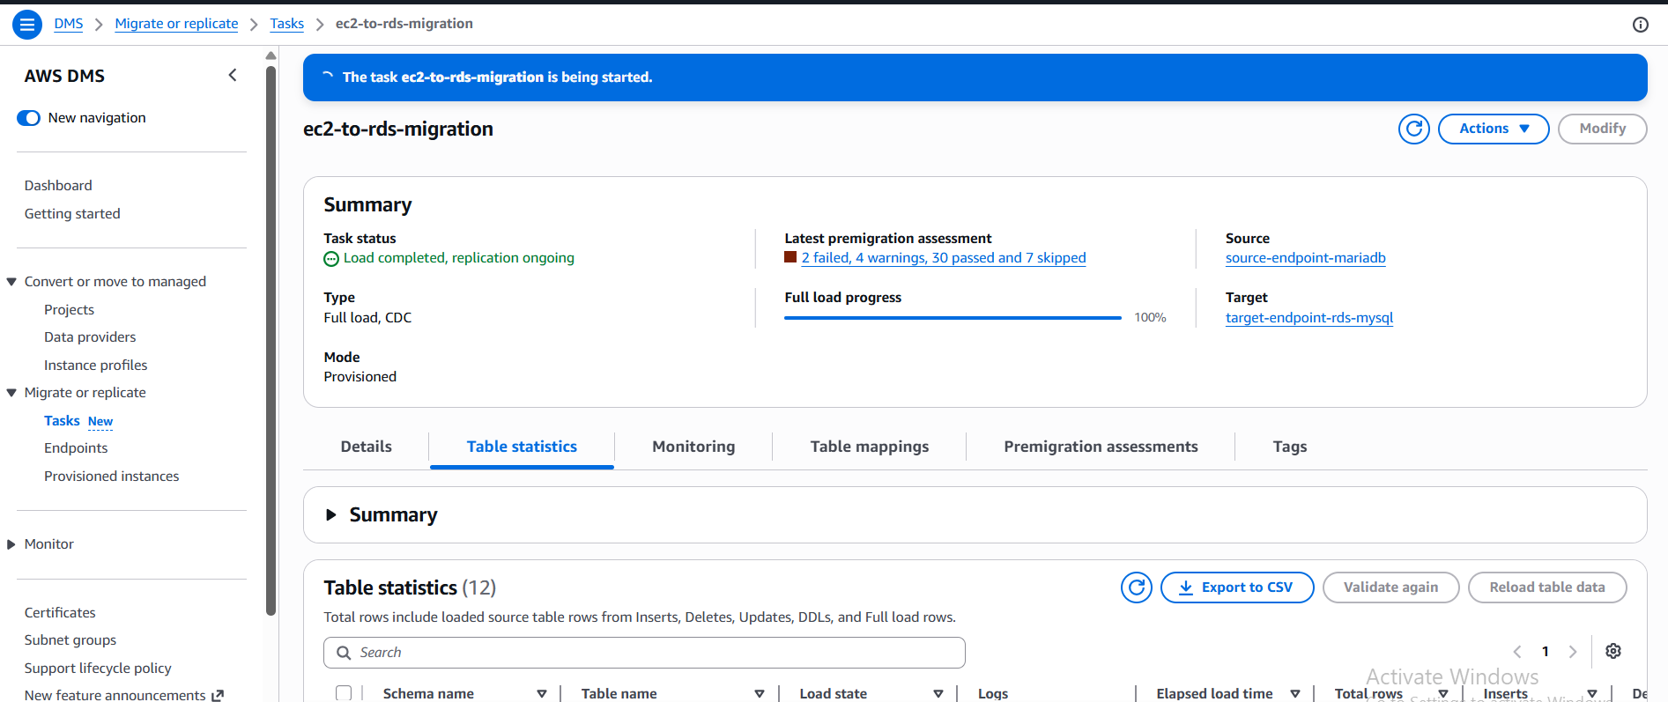

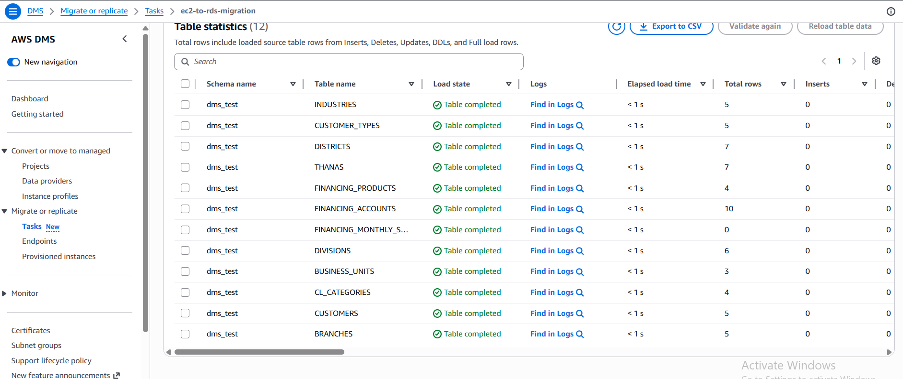

- Validate Migration
SELECT COUNT(*) FROM CUSTOMERS; —5
SELECT COUNT(*) FROM FINANCING_ACCOUNTS; —10
SELECT
COUNT(*)
FROM INFORMATION_SCHEMA.TABLES
WHERE TABLE_SCHEMA = 'dms_test'; —12
SELECT * FROM CUSTOMERS; —5 records

These query returns the same results in both source and target databases;

- Test CDC
Insert into source:

INSERT INTO CUSTOMERS
(
CUSTOMER_ID,
CUSTOMER_TYPE_ID,
CUSTOMER_NAME,
CUSTOMER_RISK_LEVEL,
LAST_UPDATE_TIME,
ADDRESS,
EMAIL,
MOBILE,
BRANCH_ID
)
VALUES
(6, 1, 'Bablu', 'Low', '2026-03-11 00:18:56',
'3/2 Patherbari, Khulna', 'bablu@spiritual.com', '0198351247576', 2);

After a few seconds:

SELECT * FROM customers;

on RDS should show the new row.

But no change in target. That means CDS is not working.

The following found from CloudWatch Logs

2026-06-15T08:35:10 [TARGET_APPLY ]E: RetCode: SQL_ERROR SqlState: HY000 NativeError: 1044 Message: [MySQL][ODBC 8.0(w) Driver][mysqld-8.4.8]Access denied for user 'dms_user'@'%' to database 'awsdms_control' [1022502] (ar_odbc_stmt.c:5078)

-- Grant full privileges on the awsdms_control database (DMS needs this)
GRANT ALL PRIVILEGES ON `awsdms_control`.* TO 'dms_user'@'%';

-- Also ensure full privileges on your target database
GRANT ALL PRIVILEGES ON `your_target_database_name`.* TO 'dms_user'@'%';

-- Apply the changes
FLUSH PRIVILEGES;

CDC works now.

- Screenshots
Source EC2 Instance
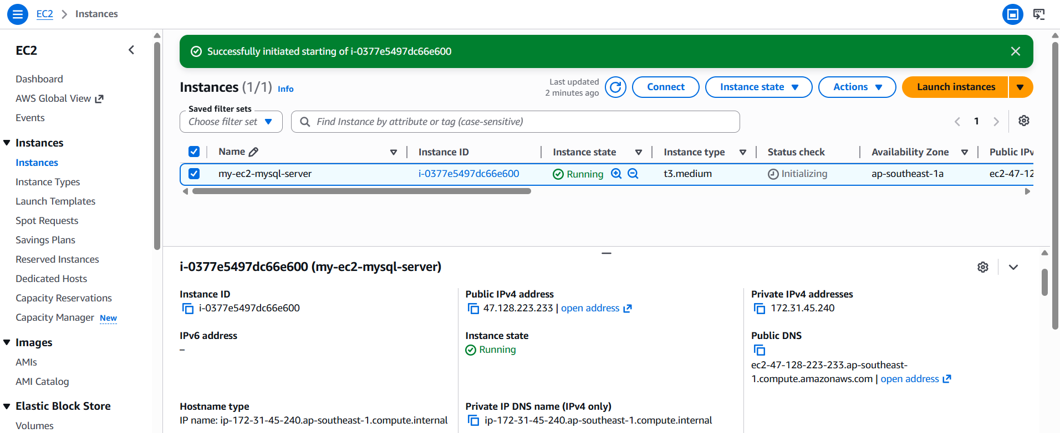

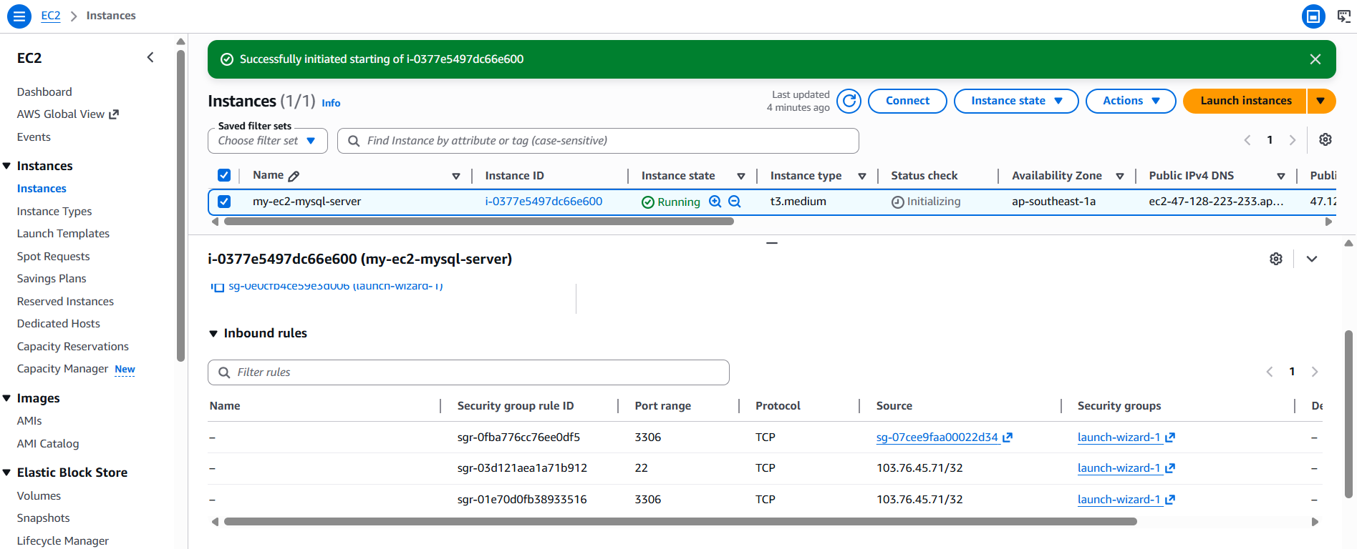

Target RDS (MySQL):
Configuration
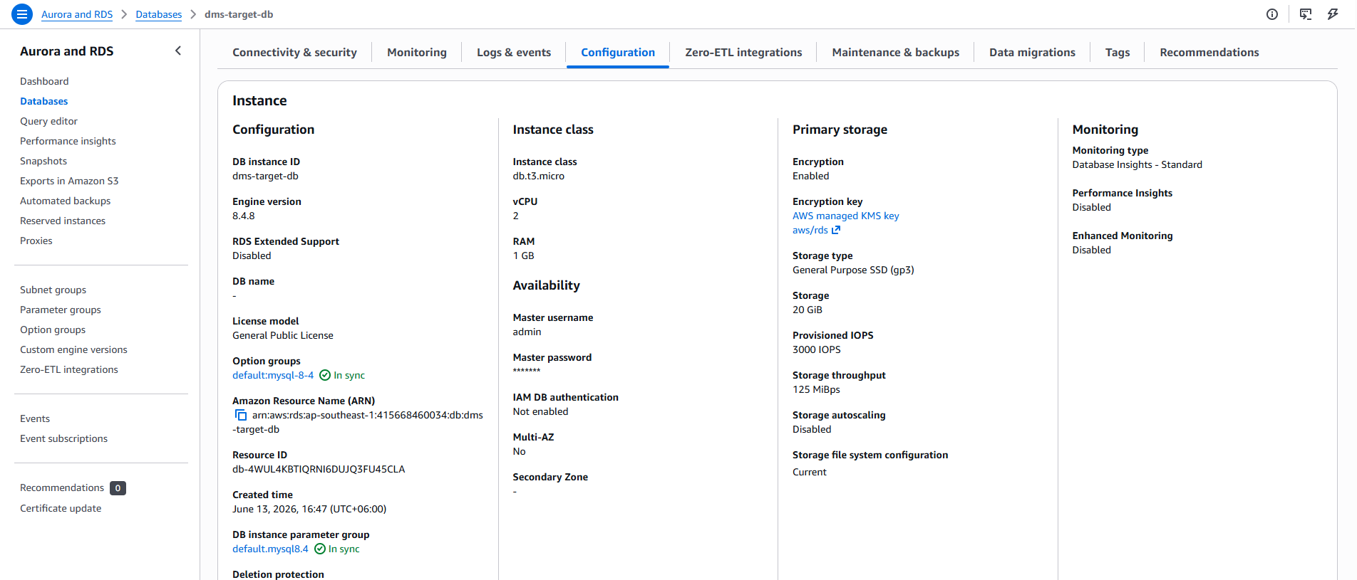

Summary and Connectivity & security
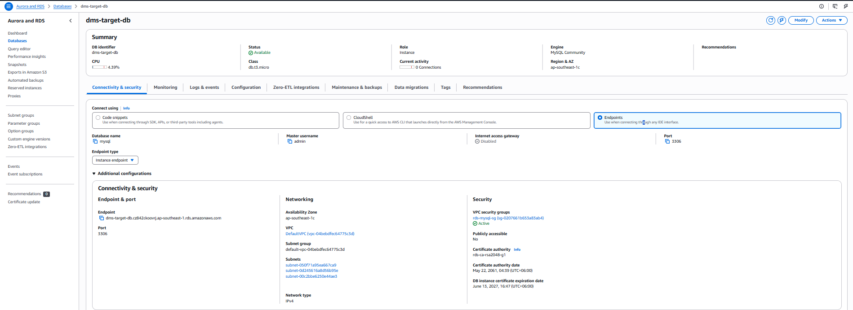

Security groups
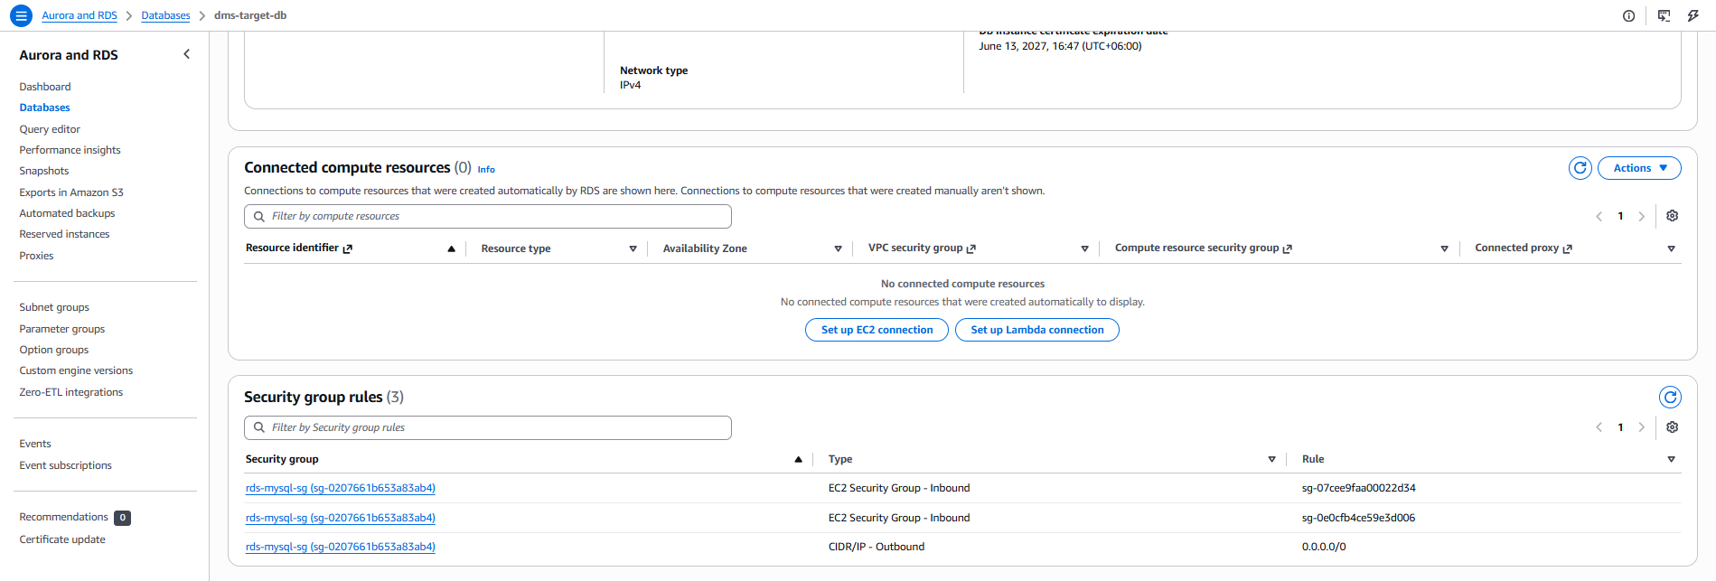

DMS Replication Instance
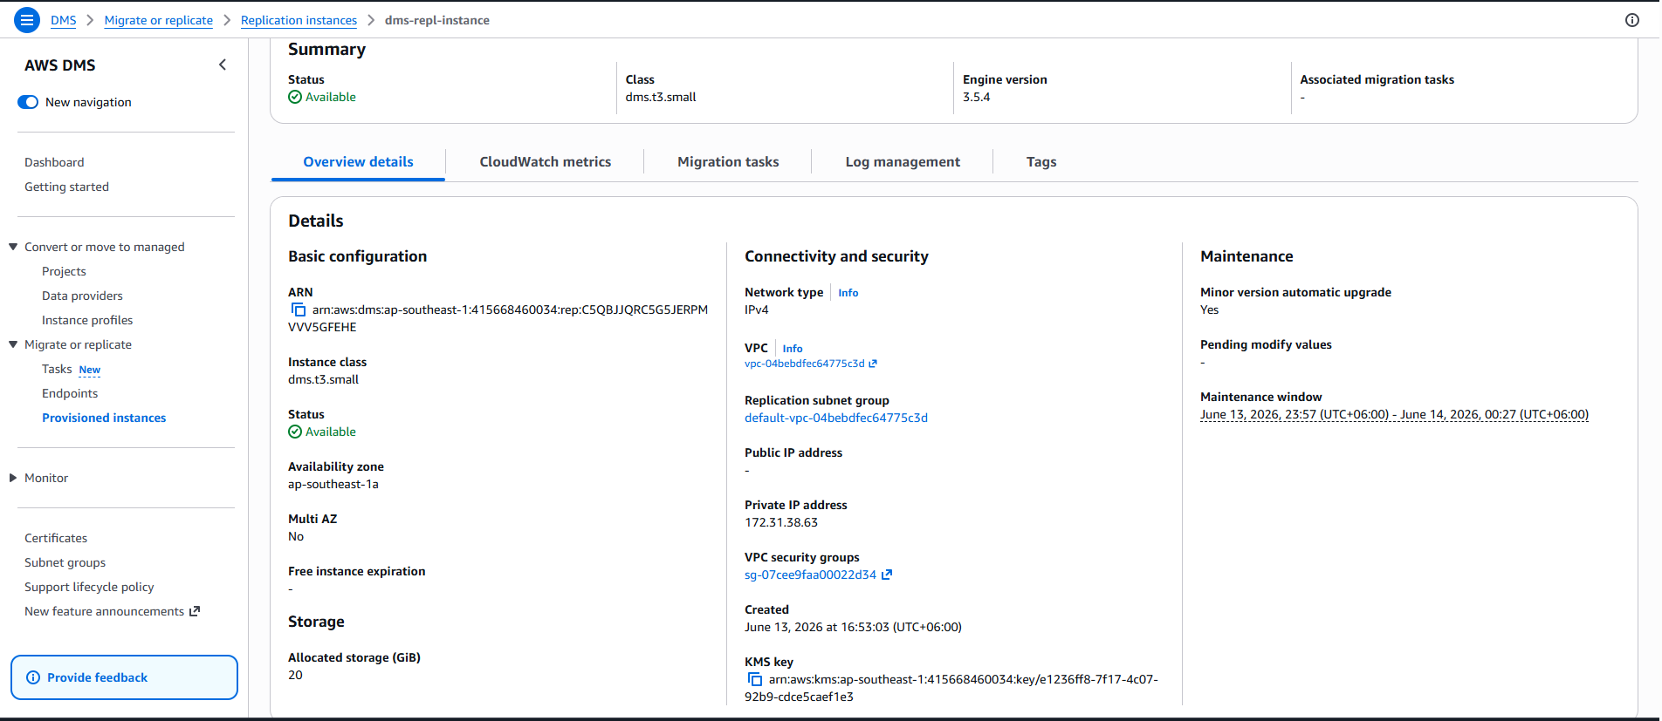
Source Endpoint
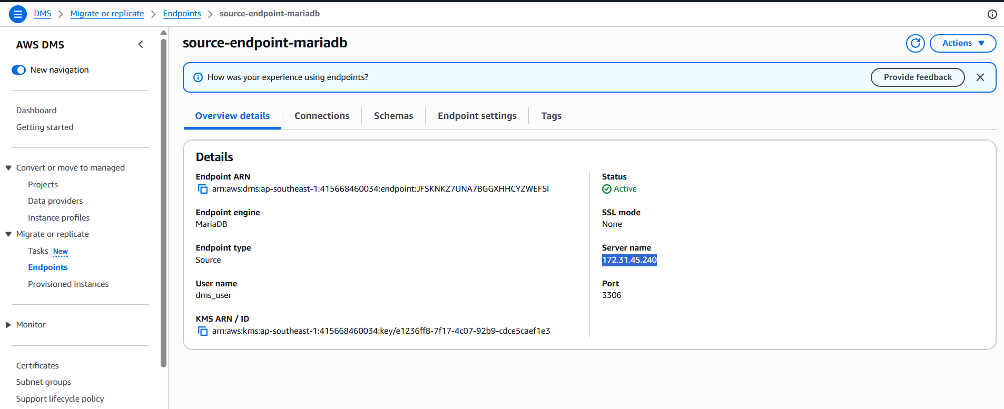

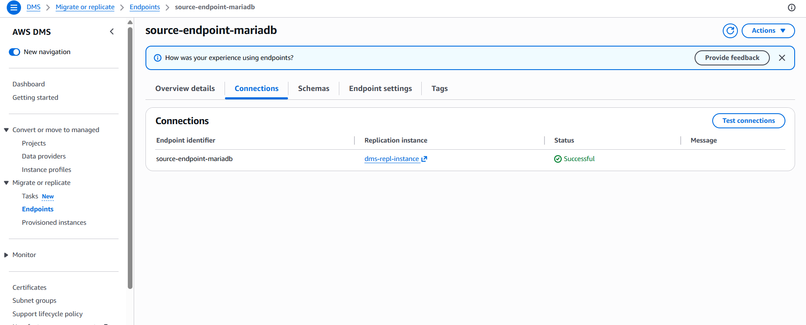

Target Endpoint
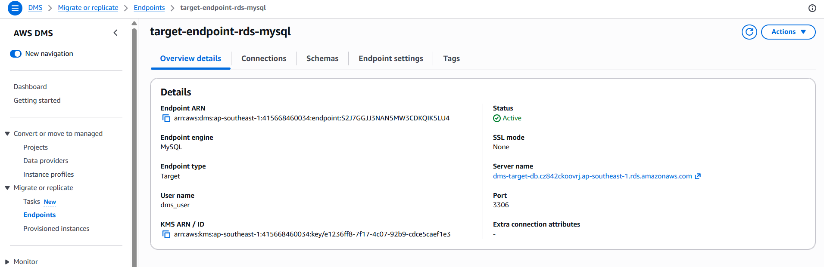

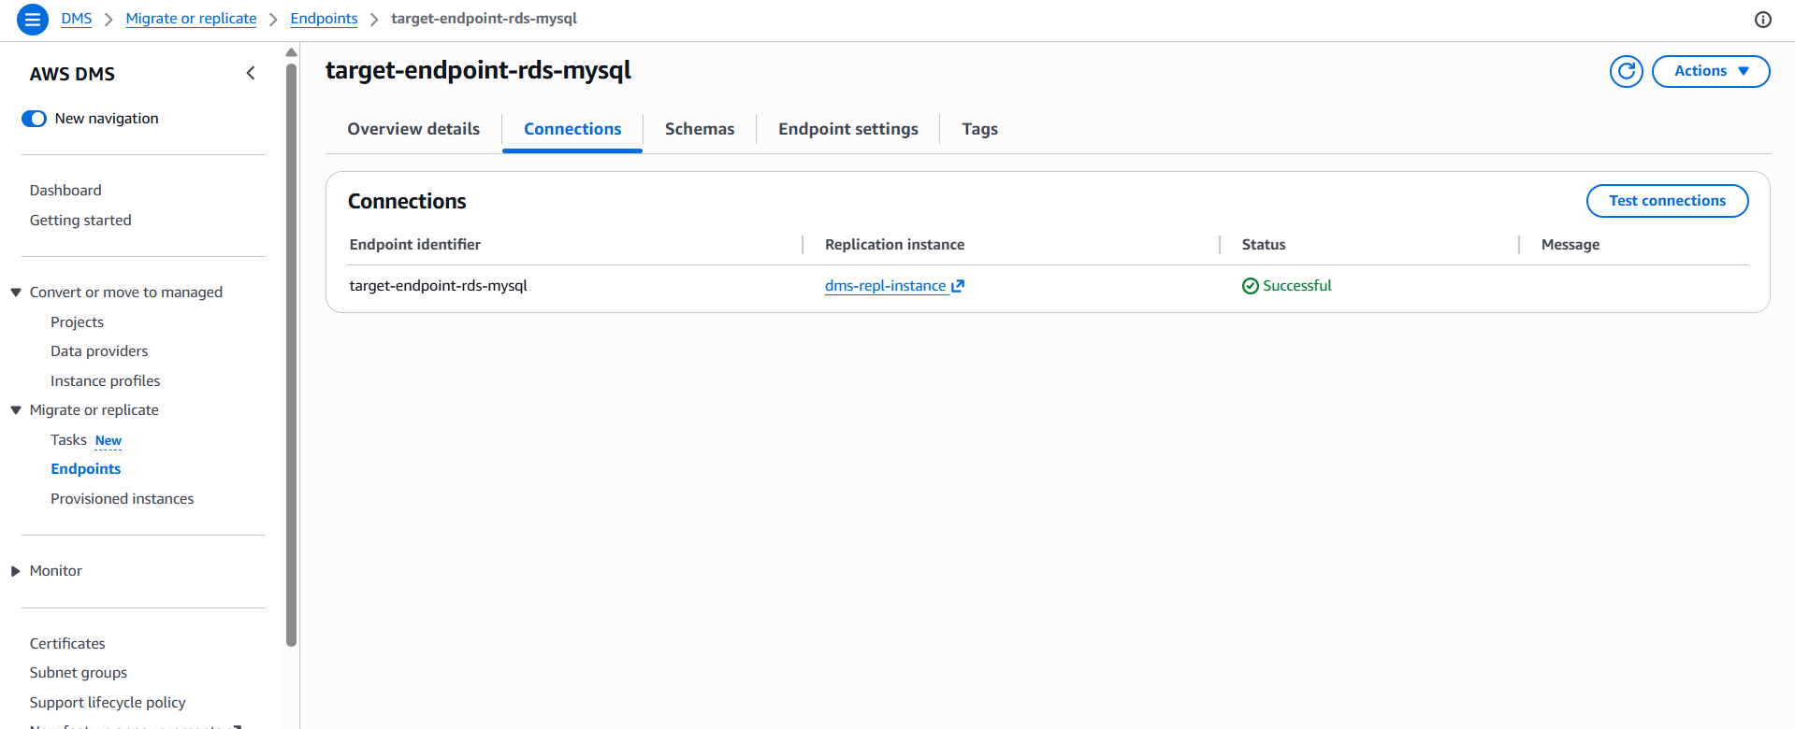

Migration Task:
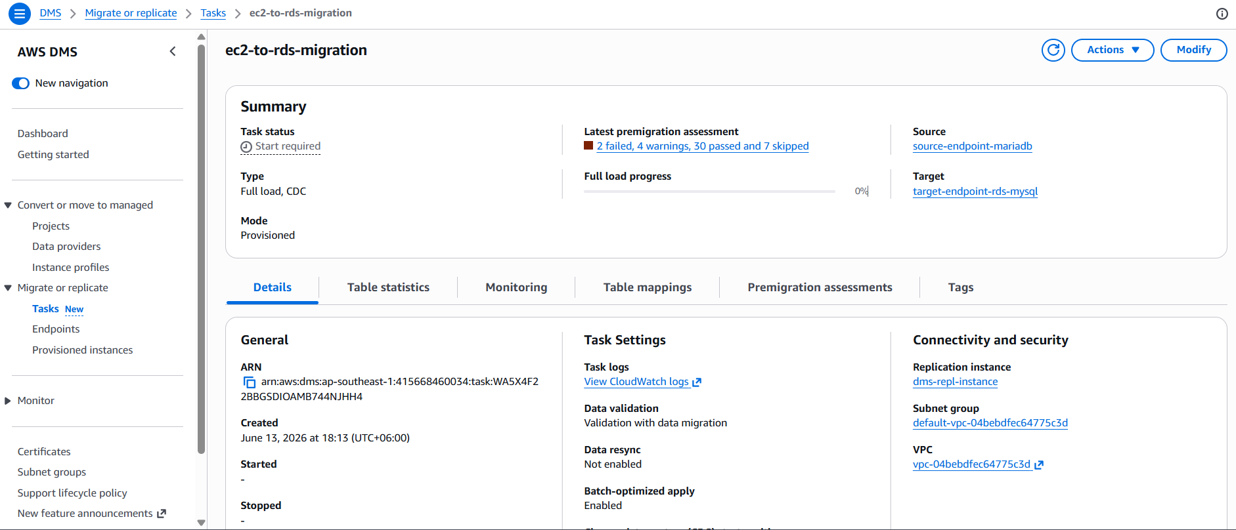

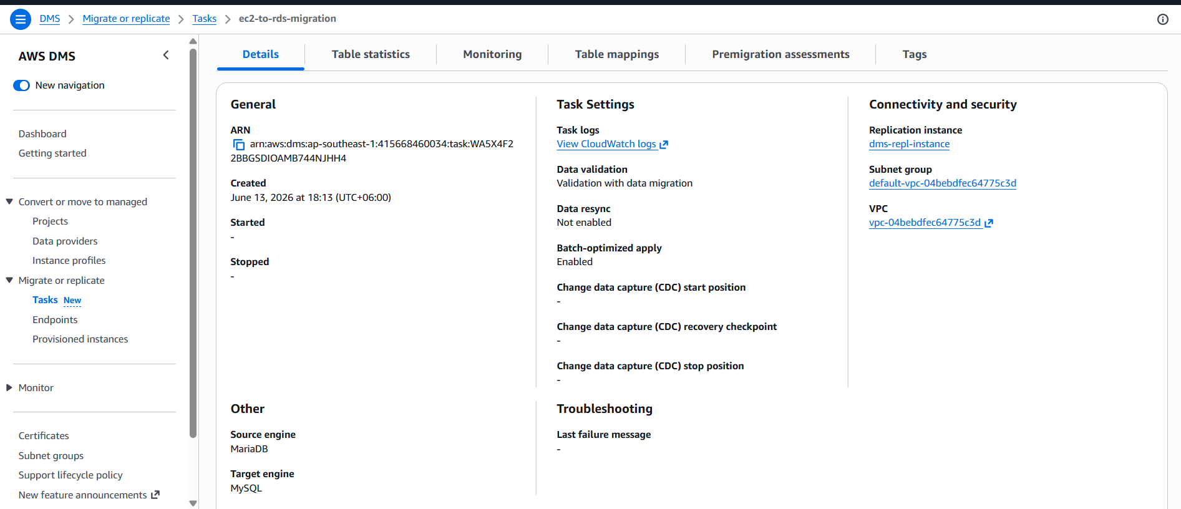

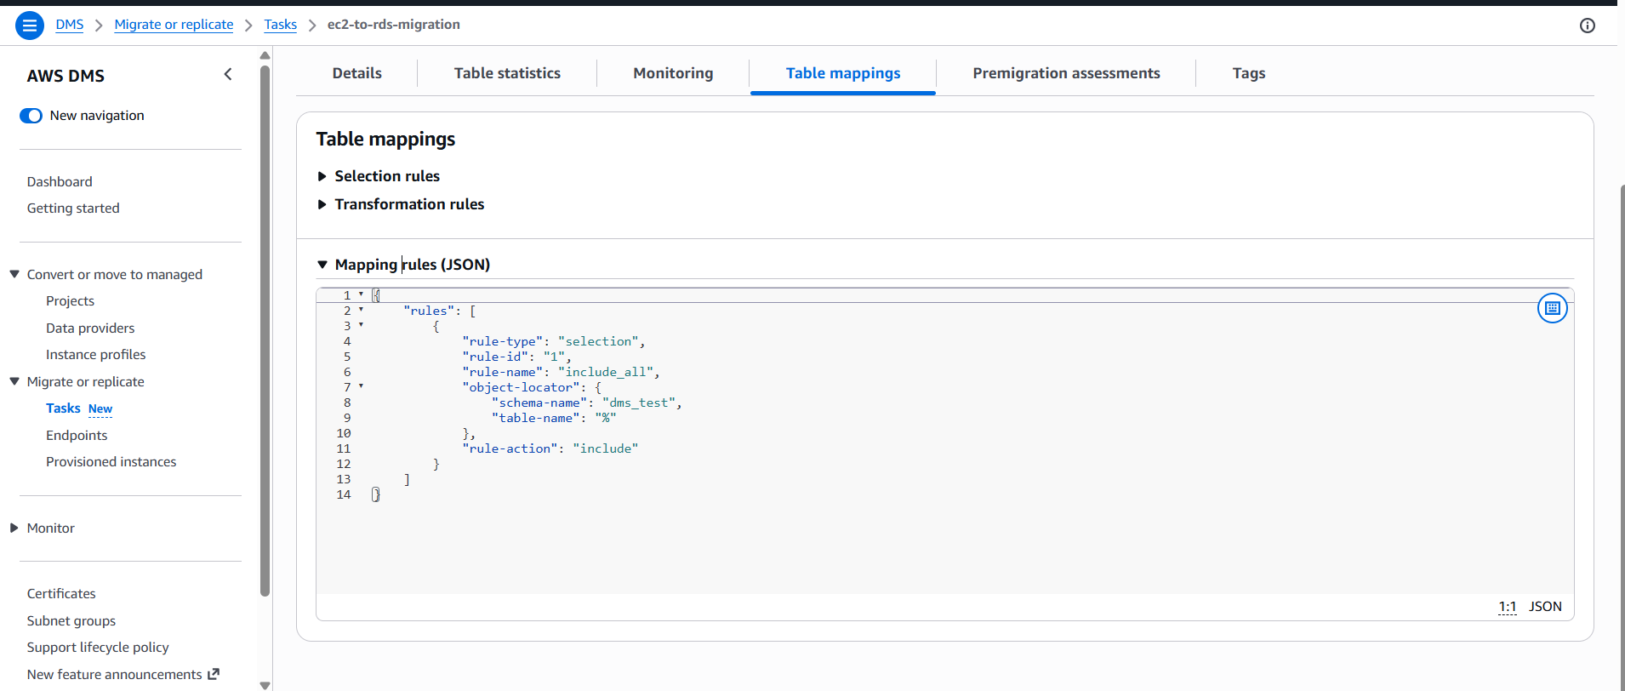

After fixation the failed items
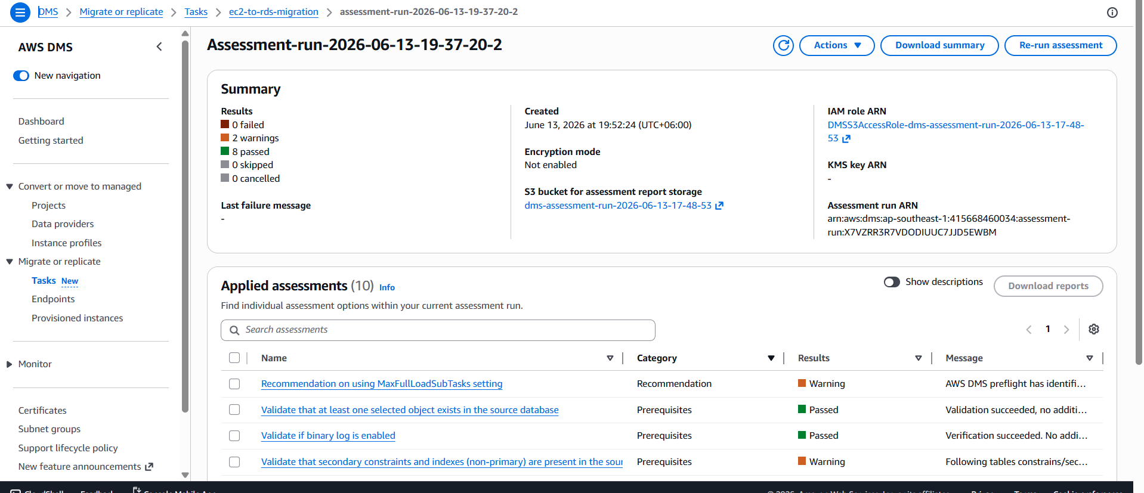

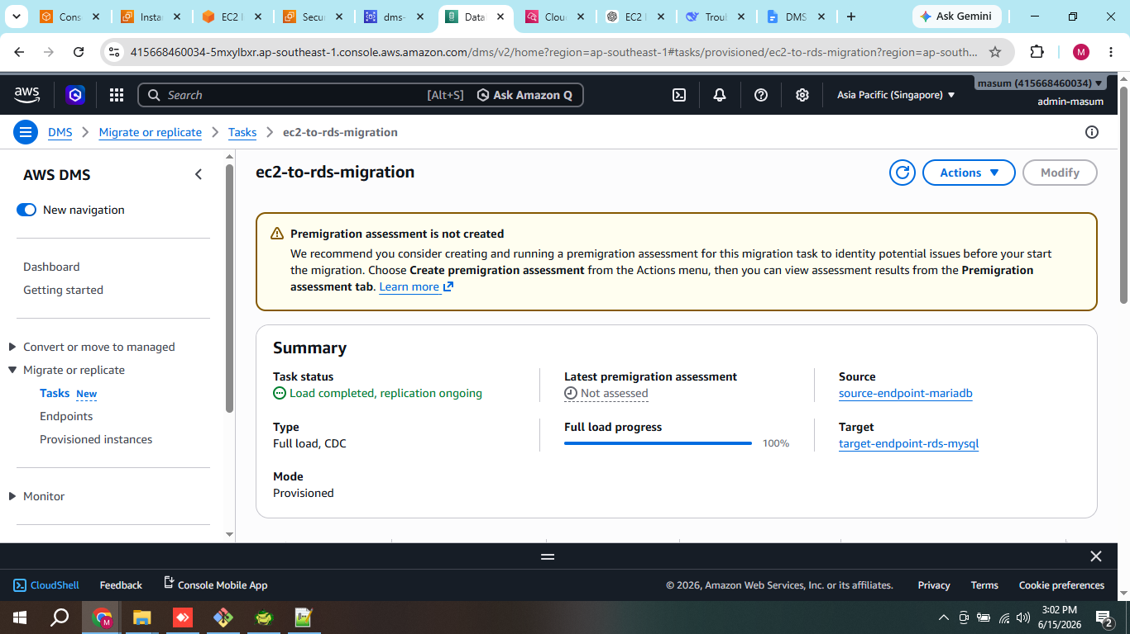

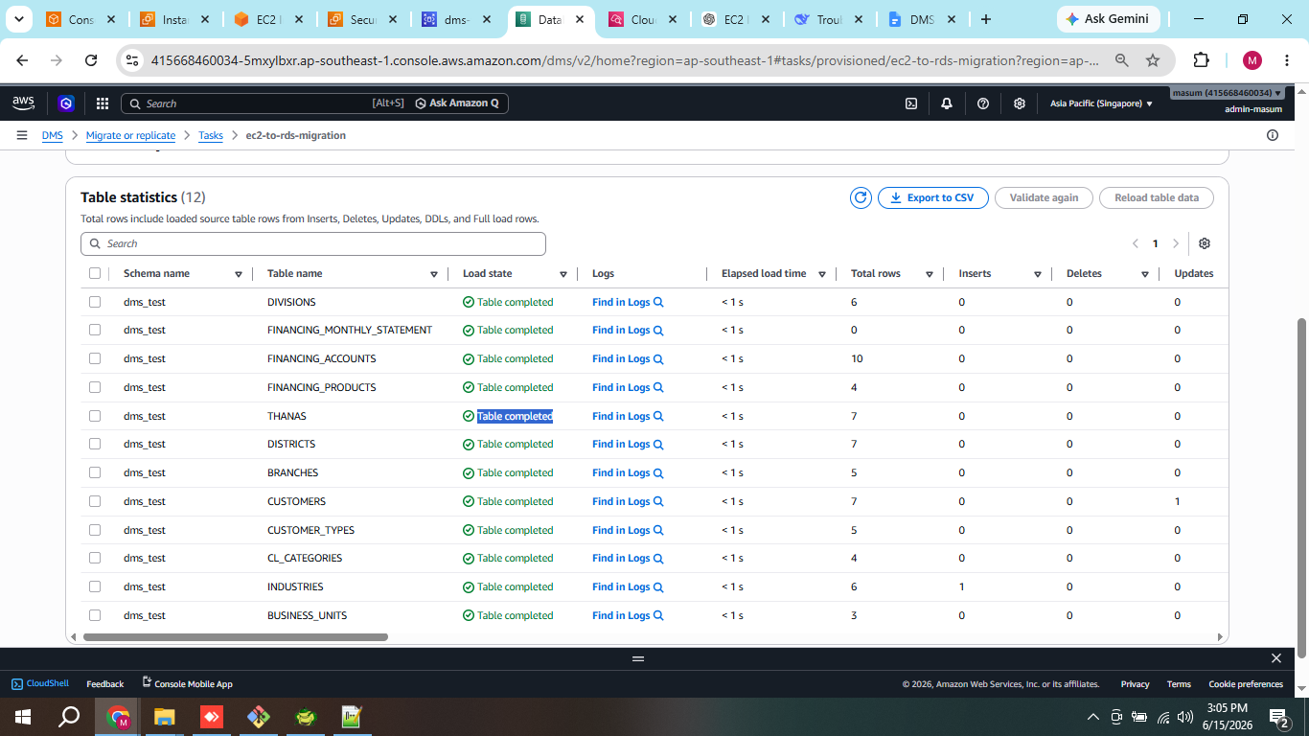

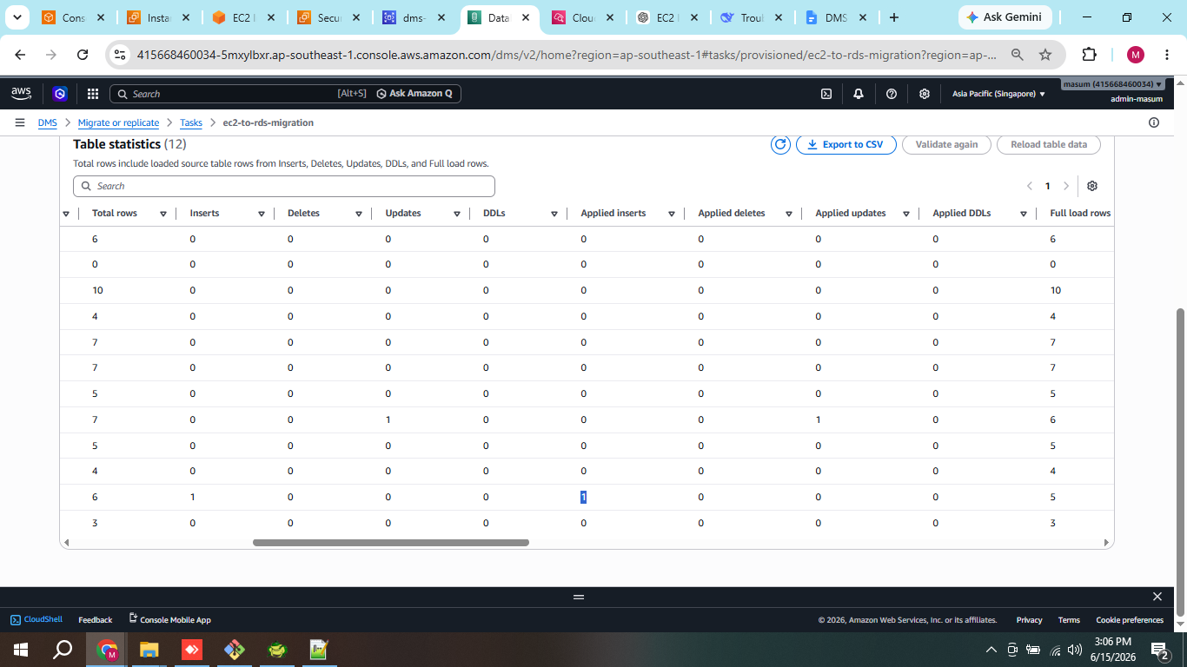

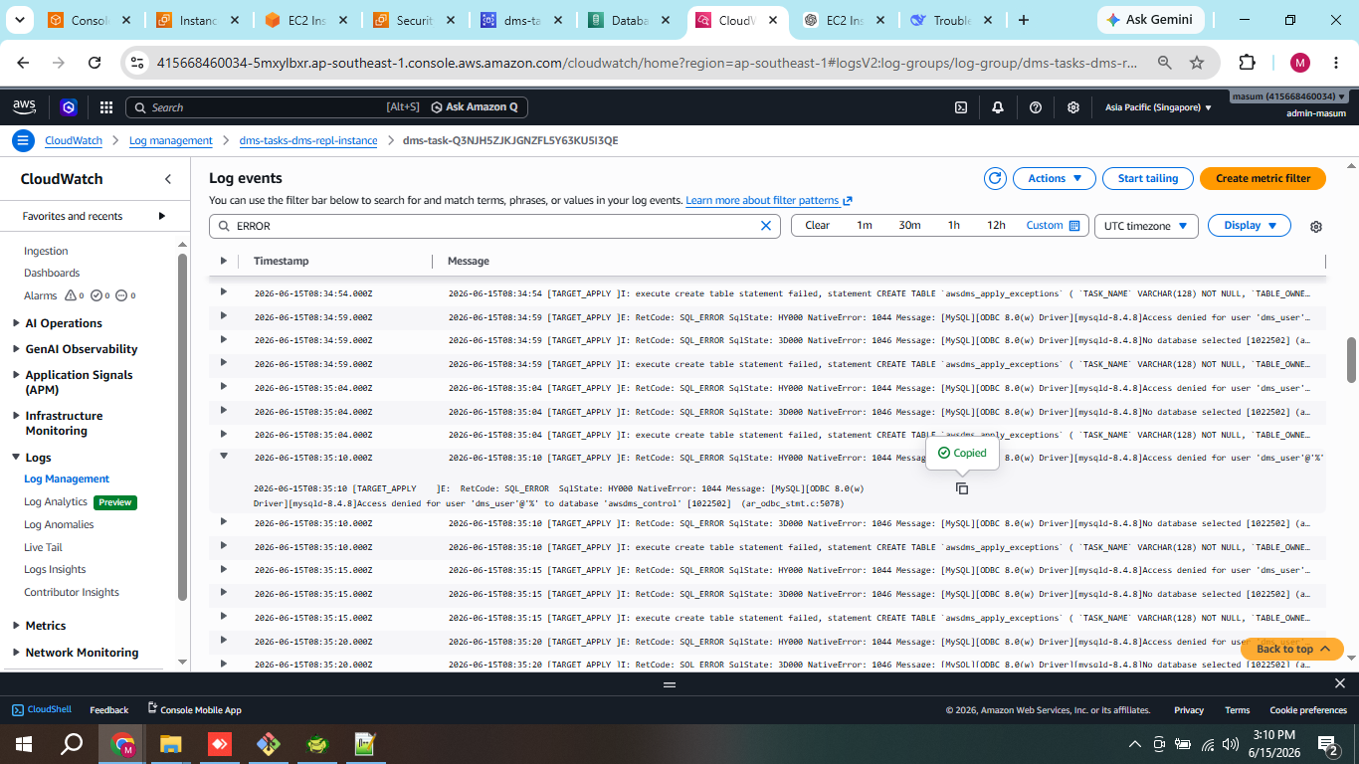

- Post Migration Tasks:
- Monitor Replication Lag
Keep an eye on CDC latency in CloudWatch metrics:
- CDCLatencySource - time between source commit and DMS reading the change
- CDCLatencyTarget - time between DMS reading and applying to target
- Set Up Alerting
Consider creating CloudWatch alarms for:
- Replication lag exceeding your tolerance (e.g., 5 minutes)
- Task failures or auto-recovery events
- Plan Your Cutover
When you're ready to switch from EC2 MariaDB to RDS MySQL:
- Stop writes to the source database
- Wait for CDC lag to reach 0
- Verify data consistency between source and target
- Point your application to the RDS endpoint
- Security Hardening (Optional)
Consider narrowing the dms_user privileges on the target now that replication is working. While DMS needs broad permissions to operate, you can scope them more tightly if desired.
- Test Failover/Failback
If this is a production migration, test your rollback plan before the final cutover.

